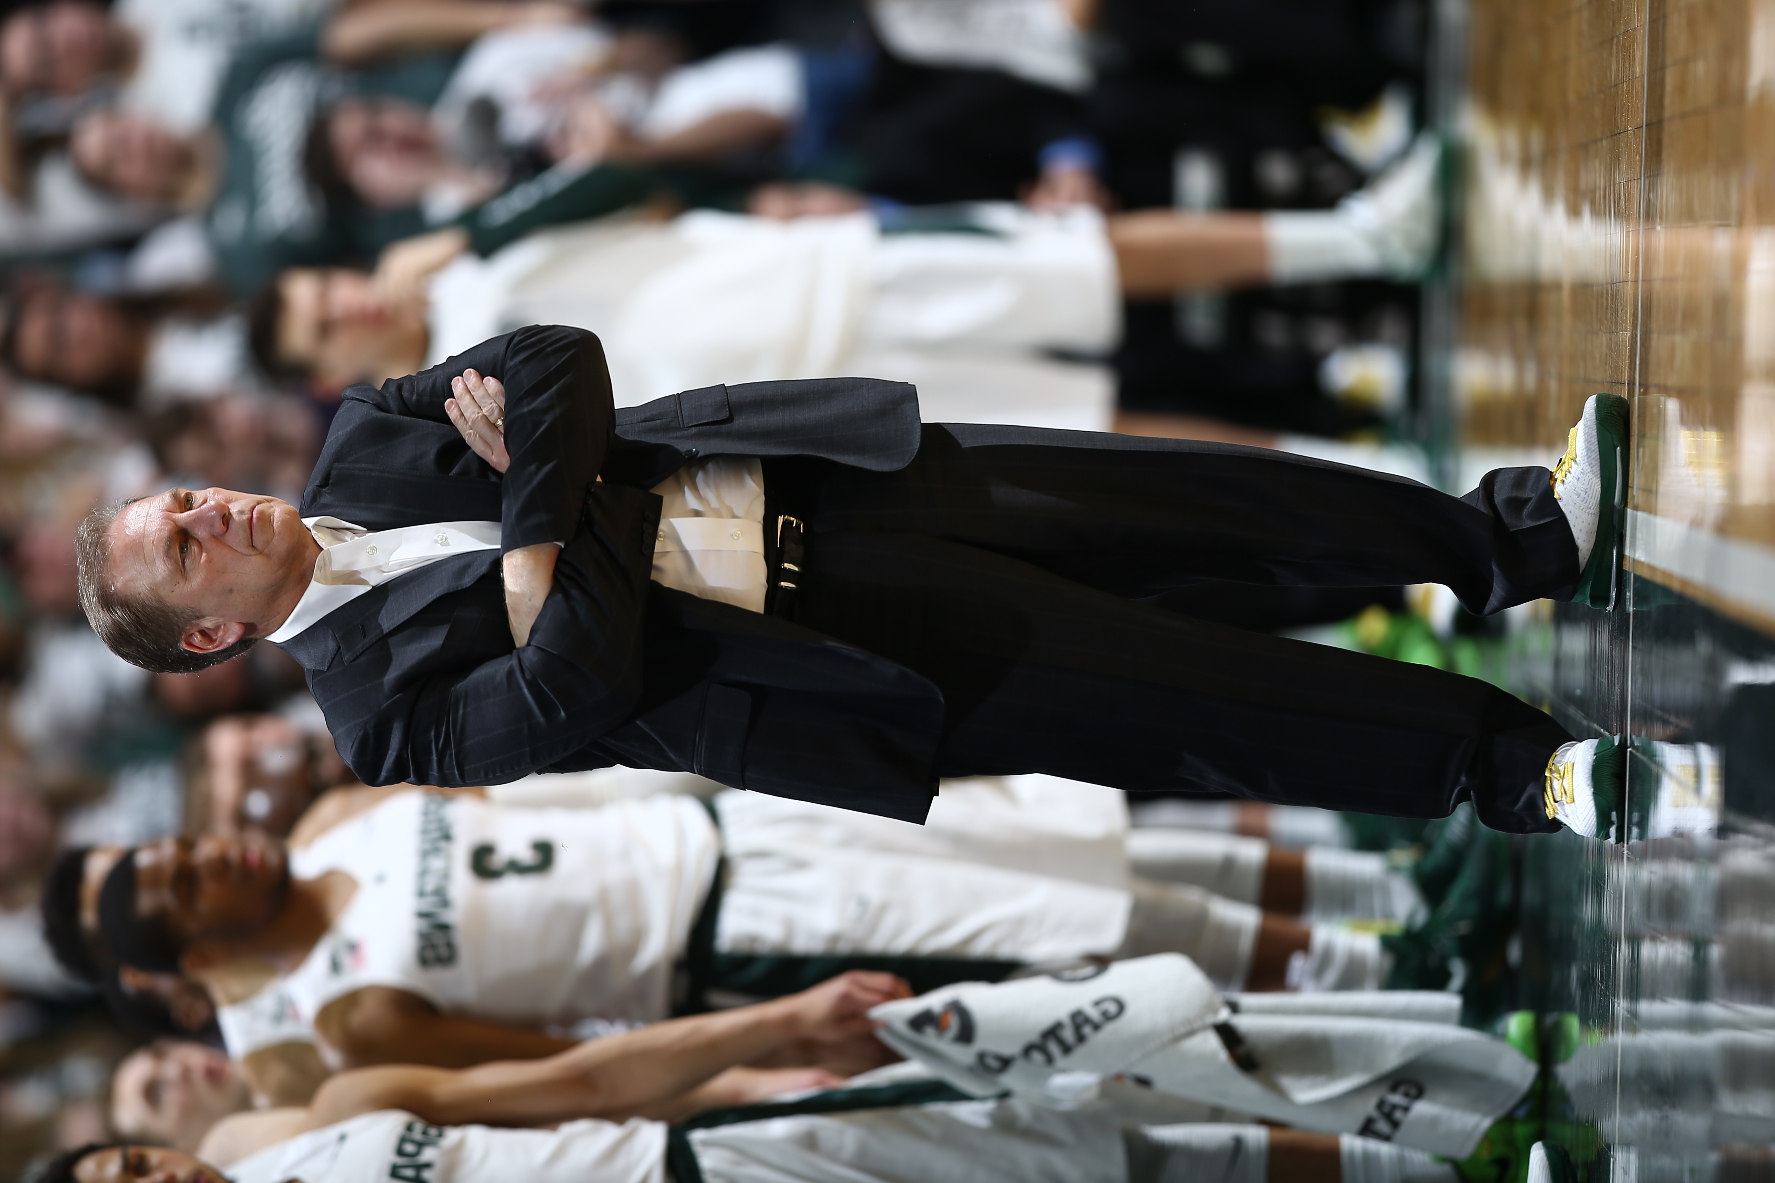
Support the American Cancer Society’s lifesaving mission by participating in the 2018 Suits And Sneakers® Challenge. Coaches vs. Cancer Suits and Sneakers® Week is a nationwide event when basketball coaches across the country unite for a common cause – saving lives from cancer. Coaches and their staff across the nation wear sneakers with their suits during games to raise awareness and help save lives by raising funds and encouraging people to educate themselves about cancer prevention, screening and early detection.

We’re teaming up with Michigan State University, Hall of Fame Men’s Head Basketball Coach Tom Izzo to fuel the fight against cancer. Join us, make a donation and wear your sneakers in style on our Game Day. All proceeds go directly to the American Cancer Society to help fund the fight against cancer

January XX, 2018

Donate $5 to wear your sneakers or
$10 to wear sneakers and jeans.

MSUCVC.COM

#SuitsANDSneakers

